|  |  |  |  |  |  |  |  |  |  |  |  |  |
| --- | --- | --- | --- | --- | --- | --- | --- | --- | --- | --- | --- | --- |
| EYE DISEASES CLASSIFICATION USING DEEP LEARNING TECHNIQUES   |  |  |  |  | | --- | --- | --- | --- | | Dr.L.Rahunathan1  *Associate professor*  *Department of Computer Applications*  *Kongu Engineering College*  Perundurai-638060, Tamil Nadu,  India,  lrahunathan@gmail.com | | Dr.D.Sivabalaselvamani1  *Associate professor*  *Department of Computer Applications*  *Kongu Engineering College*  Perundurai-638060, Tamil Nadu,  India,  sivabalaselvamani@gmail.com | | |  | |  | | | Mr. Arun Kumar M2  *PG Scholar*  *Department of Computer Applications*  *Kongu Engineering College*  Perundurai-638060, Tamil Nadu,  India,  arunkumars.23mca@kongu.edu. | Mr. Boopendhiran S3  *PG Scholar*  *Department of Computer Applications*  *Kongu Engineering College*  Perundurai-638060, Tamil Nadu,  India,  boopendhiranm.23mca@kongu.edu. | | Miss. Nanthitha K4  *PG Scholar*  *Department of Computer Applications*  *Kongu Engineering College*  Perundurai-638060, Tamil Nadu,  India,  nanthithas.23mca@kongu.edu. | |

***Abstract—******Eye diseases range from common eyesight errors to serious conditions like cataracts, diabetic retinopathy, and glaucoma will lead to blindness if it is not treated. If eye diseases are not discovered early, they may lead to vision problems like ophthalmalgia, photophobia, and conjunctivitis. The main motive of the paper is Early diagnosis, which helps a person to avoid vision loss. The treatment should be more effective initially to preserve the person's eyesight. Most of the researchers focus on one disorder of the eye, but our study classifies three disorders to predict the diseases earlier and prevent a person from eye diseases. Deep learning is primarily used for classifying images, in the main of medical images. The DenseNet and ResNet techniques are used for classification, where they deeply extract features through their dense layers and skip connections. The dataset is taken from the Kaggle repository and consists of 4000 medical fundus images. It is a multiclassification classifier where it consists of four classes and each class has 1000 images.***

***Keywords—Cataract, Diabetic Retinopathy, Glaucoma, Vision loss, retinal disorder.***

1. INTRODUCTION

In the human body, the eye is the most complex sensitive sense organ which works on light reflection through a natural lens called convex, which is made up of transparent material for humans to visualize the things around us. If the eye is invisible, we can’t see any color or objects. The eye is considered an optical device and is spherical in shape. The outer layers sclera and the inner layer of choroid are the essential to keep the eye light tight. The components of an optical axis consist of four lenses: the first lens cornea denotes the clearest part of the eye, it mainly focuses on light from the outside of the world, the aperture which is called the pupil in a diaphragm which controls the light entering to the eye interior. The crystalline lens completes the remaining focused light of images and processes on the retina. The light energy is converted into electrical energy by the retina of three cells namely rods, cones, and photosensitive ganglion. Cataracts, diabetic retinopathy, and glaucoma are major diseases that affect a person and may lead to vision loss. The early diagnosis prevents people from eye loss and protects the eyes from various diseases. Glaucoma damages the optic nerve and happens in the eye's front layer when the fluid builds. The pressure increases when extra fluid builds in the eye which affects the optic nerve. Cataracts affect the inner part of the eye lens to get foggy or cloudy. Cataracts happen whenever the proteins get broken down and aggregated together. Due to diabetes, the person is affected by diabetic retinopathy at the back of the eye where the blood vessels are affected in light-sensitive tissue. It is a multiclassification classifier consisting of four class labels: cataracts, diabetic retinopathy, glaucoma, and normal eye. Deep learning is used for image classification, with Convolution Neural Network architecture. Specifically, DenseNet and ResNet architecture have been used for implementation for better classification.

II. LITERATURE SURVEY

**Yilin Hou et al.,** [1] diabetic retinopathy, the Deep neural networks exhibit impressive performance by using the system of computer-aided diagnosis. The large labeled images are exhibited through DNN. The interpretability and accuracy may deteriorate by taking the data as limited. The prior information is valuable to excavate for the situation. In this paper, for improving the accuracy of classification and interpretability the researcher explores the tracking information in the eye compared to an early detection of DR system. The ophthalmologists collect the gaze maps from the patient's eye through the tracker during the DR diagnosis process. The ophthalmologists do investigations by gaze maps. At first, the fundus images are collected and the data is based on the two approaches in image fusion. The guiding of the DNN model, the supervised mask is referred to by the gaze map as weighted. The strategy in which the learning of class adaptive map is used to improve the interpretability in the model. The class activate map provides good accuracy and improves interpretability by detecting the DR model.

**Ziting Peng et al., [2]** The approaches of conventional eye diagnosis are more time-consuming, subjective, and densely dependent on the clinicians. The Vision Transformer (ViT) and the CNN networks are combined to introduce the fundus images as diagnostically infrared for improving eye disease diagnostics and following the conditions of the Fundus Neoplasm, Disk Swealing, and myopia. The main purpose is to find the diagnostic efficiency and accuracy. The methods used in the research are CNN and ViT for analysis and the device that captures the nearly infrared images of the fundus which has high quality. The 640 images are employed for each condition. The data are distinguished into four types. The HCI is integrated with infrared images customizing both the applications of clinical and purpose in research. The architecture of VGG19 and VGG16 are compared with the ViT model. The accuracy of the Vision transformer is 94.35% for finding infrared images. **Teresa Araújo et al.,** [3] diabetic retinopathy, the process of screening will be error and tiresome and sometimes the treatment is adequate for the patient. The deep learning method has proven the performance as promising with a system of CAD computer-aided diagnosis and the clinical application becomes a hindrance while using the behavior of a black box. In this paper, the researcher proposed a DR|GRADUATE where the deep learning CAD systems support the decision provided medically estimate the uncertain predictions, and allow to measurement of the decision that is trusted by the ophthalmologist. The approaches of Gaussian sampling have been built by the framework of multiple instances and allow the DR|GRADUATE where the image is inferred and associated in the explanation of the map and the predictions are uncertain while training the labels image-wise. The achieved Cohen’s kappa value is 0.71 t0 0.84 with different datasets. The low-prediction image has high kappa values, which indicates the valid prediction quality is uncertain. The images that have bad quality have higher uncertainty and the images that are not suitable for the diagnosis lead to the prediction as trustworthy. They also test unfamiliar images and detect the outliers. At last, the result shows that grading in DR severity has a second opinion and gives the great potential on the DR|GRADUATE.

**Krishnan Sangeetha et al.,** [5] Diabetic Retinopathy is a disorder in microvascular that affects the eye and its long-term effect on Diabetes mellitus. The glucose level is increased in blood and variation in pressure levels and the possibility of developing DR is proportional to the human's age and diabetes duration. The person who is affected by diabetes can have diabetic retinopathy disease on the eye. The vision threat affects people as one-fourth of diabetic retinopathy. The classification and earlier detection should take and assist the patient with the effects of diabetic retinopathy. Diabetic retinopathy can be classified into several stages’ mild, moderate, severe non-proliferative, and proliferative DN.  The main problem is detecting diabetic retinopathy is time-consuming and it also requires the ophthalmologist to examine the eye retinal which is affected by fundus. The analysis is done in tonometry, Visual Acuity testing, and dilation. Earlier detection should need to avoid diabetic retinopathy to reduce the blindness in risks. The automated method used in diabetic retinopathy gives good progress in image classification, machine learning, and recognition of patterns. The accuracy for the RestNet algorithm is 96.6%. **Shanmugam P et al.,** [6] The damage in optic nerves that causes complete and fractional visual misfortune is due to Glaucoma. The reason for glaucoma is due to increases in the pressure in the intra-ocular of the eye which affects the optic nerve. The images of the retina give the data for the eye is indispensable. In this research, the technique of glaucoma recognition is used and it estimates the fundus images to CDR. The size of an optic cup and optic disc can employ and determine the glaucoma present. The primary step in glaucoma is the segmentation of the optic cup and disc. For achieving the decisions in clashing, the errors are reduced and features are decreased. The proposed work for the research mainly focuses on extraction features, image acquisition, and stages involved in the acquisition of images. The Au-Net is utilized, and the stages of feature extractions are segmented in an optic cup and optic disc. The values based on CR; glaucoma images are classified by using a random forest algorithm. The proposed work has been done with different methods such as Full, Original, and Deformable U-net. It provides a better accuracy of 99% and segmentation of 14%, where the original U-net is compared. **Muhammad Arsalan et al.,** [7] The early diagnosis can help to prevent blindness when glaucoma is affected. When the diseases are affected in the optical disk, it segments and localizes the optical disk immediately for diagnosing accurately. There are two parts presents in the optical disc namely optic cup and neuroretinal. In this proposed work, the problem faced on the optical disk and optical cup for segmentations is modeled in a semantic pixel labeling-wise and acts as the bridge between the segmentation of semantics and images in medical. They do not follow any pre- and post-steps in Preprocessing. The optical cup and optical disc are evaluated for segmentation and offered resource and computational requirements along with accuracy in the state of the art. The implementation is done by real-time screening of automation in glaucoma disease. **I. de Zarza et al.,** [8] The paper is about training on three stages and methodology for the state of the art in network architecture. The images are trained on a previous image and tuned in three steps in an iterative manner. First, freeze all the layers and retrain an image completely to train the architecture to achieve high accuracy and high reliability. To improve the performance, a dataset consists of sample fundus images as17.070 as colored and includes two class labels as normal and abnormal. The evaluation of extensive using models like Restnet50, VGG16, and InceptionV3 are implemented with variants in the proposed method of EfficientNetV2 and Efficient Net. In the proposed methodology, obtain accuracy and F1-score at every stage. The parameters are taken and compared with other alternatives as slowly as possible to get high precision and results are achieved through a system. **Ying Xue et al.,** [9] Glaucoma causes blindness where the early detection and treatment as early for managing the glaucoma disease. For isolation, one feature is not to monitor the glaucoma progression. The proposed work is done on the Multi-Feature Deep Learning (MFDL) which centered on the Intraocular Pressure (IOP), Visual Field, and Colour Fundus Photo Graph (CFP) for classifying glaucoma in four levels. The classification, screening, and detection are a three-phase framework for diagnosing glaucoma from coarse to fine. The samples of 6131 are trained and samples of 185 are tested. The accuracy for MFDL, CFP, Visual Field-Feature Deep learning, CF-DL, and VF-DL attain accuracy of 0.84,0.51,0.48 and 0.72. The accuracy varied between 7.50% and 17.9% the seniors ranged from 6.30% to 7.50% and the experts ranged from 5.40 % to 7.50 %. The typical diagnosis duration per patient in MFDL amounted to 5.96 seconds. The prospective model holds promise in supporting ophthalmologists with swift and precise glaucoma diagnosis, thereby enhancing the clinical handling of this condition. **K Ashwini et al.,** [10] The term Diabetic Retinopathy refers to a medical term that affects our sense organ of the eye. Early diagnosis can help people prevent blindness. Diabetic retinopathy occurs because of diabetes. The diagnosis takes lots of time and is more expensive for ophthalmologists and also risks of incorrect diagnosis. For good treatment, the ophthalmologist offers a computer-aided diagnostic system in computer-aided provides a careful accurate, and efficient diagnosis. The feature extraction depends on decomposition in multiresolution used in Discrete Wavelet Transform and CNN is used for classification for grading the images of DR. The preprocessing techniques are used to find the images which affected by fundus in contrast level. The datasets in images are not balanced. During the process of training the oversampling checks whether the images are present in each grade category. The accuracy for classification achieves 92% and 93% for all diabetic retinopathy stages and the proposed method provides a higher ranking for each current approach.

III. PROBLEM STATEMENT

The person may not be aware of whether they were affected by diseases until the symptoms arise. They are affected quietly in the absence of visible symptoms till serious destruction takes place and lose their standard life if it is not treated early. To detect eye disease as much earlier, early diagnosis plays a major role in medical images which will prevent the person from vision loss. The DenseNet and ResNet architecture is used for the classification where it exactly finds the diseases by their layers from the images.

IV. SYSTEM MODEL

The advanced techniques of DenseNet and ResNet architectures are used for the classification, especially in medical images. In training, the layers of these models learn the features and recognize the patterns that are associated with several eye diseases such as diabetic retinopathy, glaucoma, and cataracts. After training the model, the new images are extracted based on the features during classification. When the person's medical image matches the class label, then the model predicts the person is affected by either of these disorders. Here, early diagnosis plays a major role in elevating awareness for patients whenever they are affected by diseases.

V. PROPOSED WORK

In previous works, most researchers mainly focus on only one eye disease for classification such as cataracts, Diabetic retinopathy, or Glaucoma. This is the research gap we identified in previous works. To overcome this, we propose an extensive approach with three eye diseases and one normal eye for classification. In previous research, they employed a single algorithm for each eye disease but we have proposed two different algorithms DenseNet and ResNet are used for classification and obtaining better accuracy.

1. *DATASET DESCRIPTION*

The dataset is taken from the Kaggle repository and consists of 4217 retinal images. It is mainly divided into four classes diabetic retinopathy, glaucoma, cataracts, and normal images. Diabetic retinopathy consists of 1098 images, glaucoma consists of 1007 images, cataract consists of 1038 images, and normal images consist of 1074 images.

1. *DATA PREPROCESSING*

Totally 4217 images, for tuning the model we pass the parameter as the size of [224,224] and take batch size as 32, class as 4, and learning rate as 0.0001 where learning rate is a hyperparameter in which weights are adjusted when we are training a model. In DenseNet to train the model as much better we rescale the images as 1./255 where it normalizes the images to scale down the values of pixels. For the representation of 8-bit images, we use 255 which it takes the intensity value as a maximum pixel. The image augmentation uses a shear range and zoom range of 0.2 where ImageDataGenerator takes the float value to zoom the images and the shear range is used for shearing transformations which apply randomly. The vertical and horizontal flip is used. The images are resized as (224,224) and shuffling is also done. The dataset is split into 80 as training and 20 as testing. In ResNet, the min-max normalization is used when the image pixel value is not critical. The RandomHorizontalFlip and RandomVerticalFlip is used to flip the images as y axis and x axis. The images are resized and shuffled for better learning. In ResNet, the dataset is split into training at 85 and testing at 15.

*3. ALGORITHMS*

*A. DENSENET ARCHITECTURE*

The DenseNet is connected as densely in a convolutional neural network. The DenseNet takes all its previous output as an input for the subsequent layer. To improve accuracy the DenseNet architecture is developed and it causes the vanishing gradient during the high-level neural networks when the images are transferred from long distances from input to output and also the passed information vanished when reaching its destination. The formula for dense net architecture is

Top of Form

$x^{\left[a\right]}$ = $g([x^{\left[0\right]},x^{\left[1\right]},x^{2},………, x^{\left[a-1\right]})$ (3.1)

A denotes the number of layers that are connected. In DenseNet it has A(A+1)/2 connections. The technique of DenseNet architecture has fewer layers when compared to other models. So, the training process for more than 100 layers is simple and easy. When we move the second layer to the third layer, the third layer takes the input from its all-previous layers not only the second layer. When we move to the tenth layer, it takes input from all preceding layers output, and also each layer produces the feature map explosion. To avoid the problem, a dense block is created and it containsa predetermined number of layers within them. The output from each dense block moves to the next layer called the transition layer and the 1x1 convolution layer is followed by max pooling which it reduces the feature map sizes. Fig 5.1 represents the architecture of DenseNet where its layers move densely and predict the output.

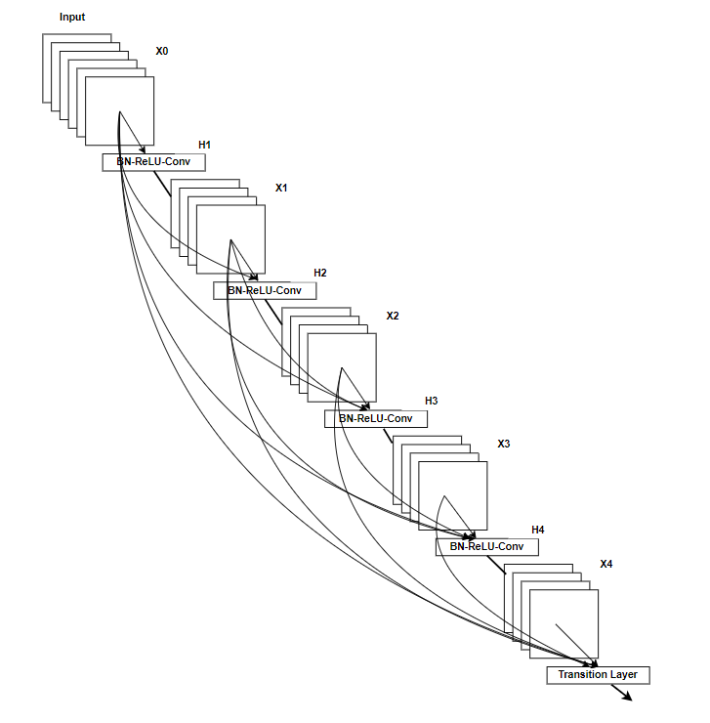

Fig 5.1 Architecture of DenseNet

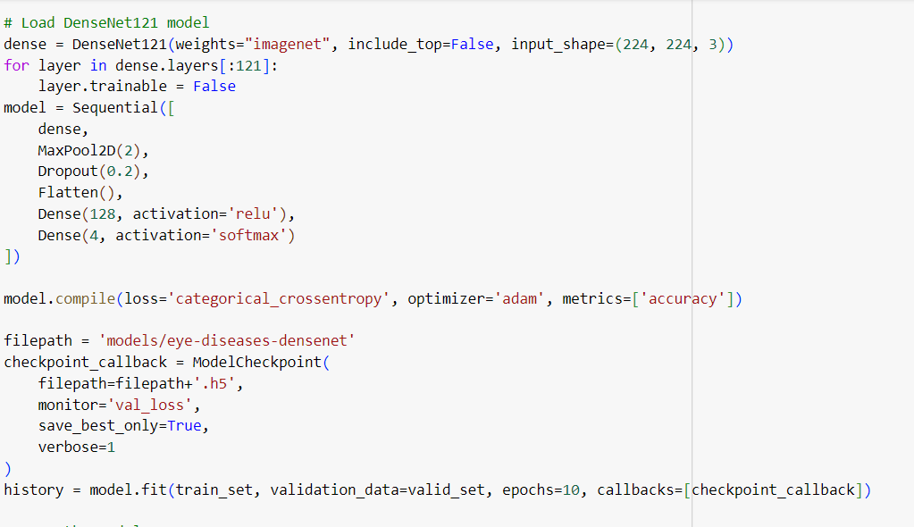

Fig 5.2 Implementation of DenseNet Architecture

Fig 5.2 represents the implementation of DenseNet architecture where it passes the hyperparameter for tuning the model for better classification and provides accuracy. The DenseNet architecture uses the activation function as relu and the optimizer as adam.

*B. RESNET ARCHITECTURE*

Residual Network is a kind of neural network. It is mainly used for image recognition tasks and used to solve the problem in deep neural network as vanishing gradients. The ResNet architecture is split into four segments where each segment consists of many residual blocks where that have different depths. The first segment is the convolution layer which it reduces the dimensions of the input images. The second segment consists of 64 filters and the third and fourth segment consists of 128 and 256 filters. The final layer is called the pooling and fully connected layer where it predicts the output. The formula for ResNet architecture is

${ x}^{\left[a\right]}$ = $g(\left[z^{\left[l+1\right]}+x^{\left[l\right]}\right)$ (3.2)

At the background, by training the neural network is difficult when the gradient descent occurs. During the back propagation, the gradients become too small which may cause the model to perform poorly and converge slowly. However, the traditional method is not supported for the problem. In ResNet architecture, residual learning was introduced and implemented in the vanishing gradient problem. The ResNet contains residual connections which allow the network to learn residual mappings through the input and output layer differences. The connections of residual are formed by appending the input layer to the output layer where the gradients move directly to the network. The ResNet architecture contains many layers and each layer consists of residual blocks.  The residual blocks perform transformations where the output layer obtain its input from the input layer. The second segment consists of three residual blocks and every layer consists of two convolutional layer and also includes a shortcut connection. The third, fourth, and fifth stages include six, three, and four residual blocks. Each and every stage consists of many convolution layers and shortcut connections. The output layer which reduces the spatial dimensions in map feature which fed into the pooling layer with activation function and produces the final output.

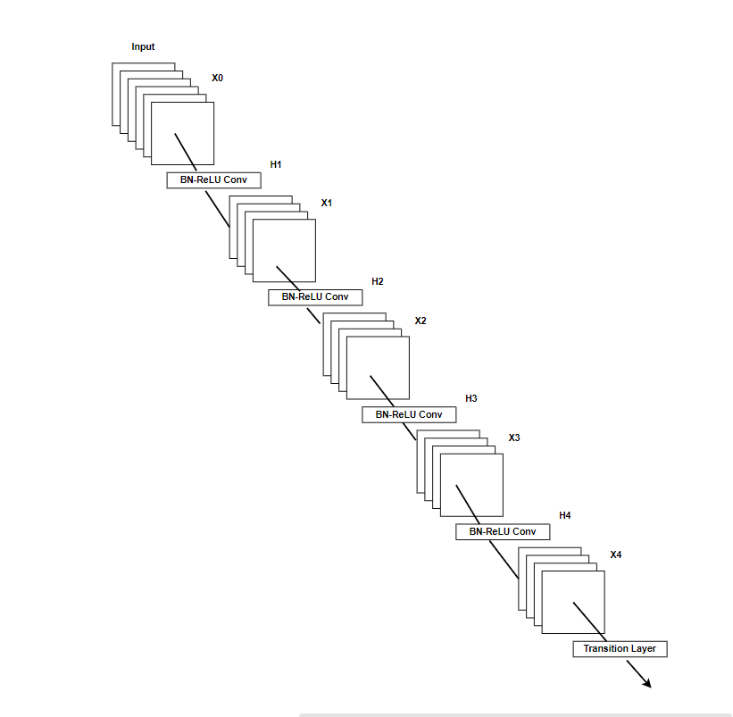

Fig 5.3 Architecture of ResNet

Fig 5.3 represents the architecture of ResNet which uses a skip connection that the input is directly passed to another layer in the absence of a transitional layer.

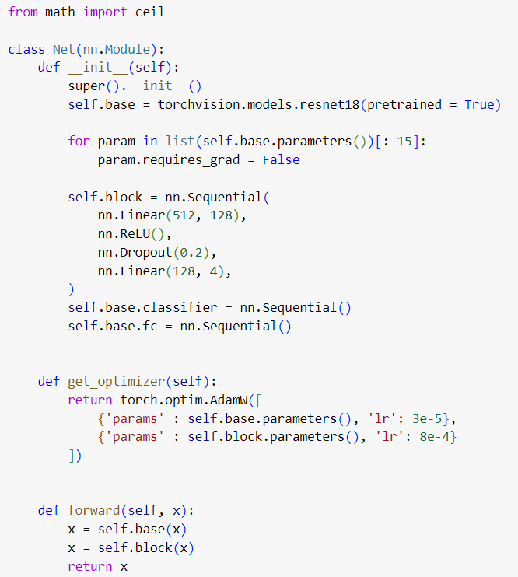

Fig 5.4 Implementation of ResNet Architecture

Fig 5.4 denotes the implementation of the ResNet architecture, where the previously trained ResNet 18 model is used. The traditional classification includes the linear layer for reducing features from 512 to 128, the Relu is used for non-linearity, dropout layer is used for regularization.

VI. SYSTEM FLOW

The implementation path of the code is shown in the flow chart that follows.

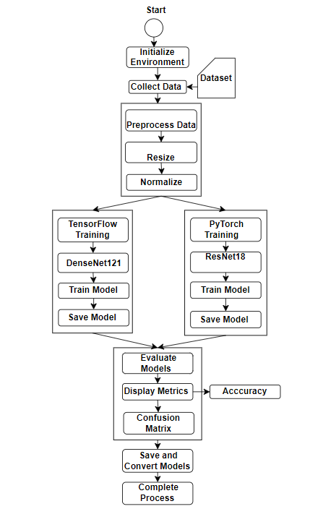

Fig. 6.1 Code Flow

The process begins with the initialization of the necessary environment and tools required for the model training process. We use Google Colab for the implementation process to run the Python code. The process begins by collecting the data, it is done by mounting the Google Drive which contains the dataset. Data preprocessing includes resizing and normalizing to reduce the size and improve pixel quality. The DenseNet architecture uses the tensor flow framework for extracting features and reducing the overfitting and also it saves and trains the model. The ResNet architecture uses the Pytorch framework for training and saving the model. The performance metrics are displayed by visualization as a bar chart. The results are stored and converted into models. Fig 6.1 denotes the code flow that how models working.

VII. EXPERIMENTAL RESULTS

The dataset is taken from the Kaggle repository and named “Eye Disease Classification”. It mainly consists of four classes cataracts, diabetic retinopathy, glaucoma, and normal eye. There are a total of 4217 images and each class consists of 1000 plus images. To predict the model, the dataset is split into training at 80% and testing at 15% for classification. For classifying images, the DenseNet and ResNet algorithms have been deployed. Early diagnosis prevents people from vision loss. The main motive of the paper is to compare both algorithms and predict which algorithm is best for classifying eye diseases. The DenseNet employed an accuracy of 95% whereas ResNet is 91%. Based on the accuracy of both models, the DenseNet has secured high accuracy compared to the ResNet algorithm. The experimental results prove that the DenseNet algorithm provides better classification when compared to ResNet algorithms.

|  |  |
| --- | --- |
| CATARACTS | DIABETIC RETINOPATHY |
| GLAUCOMA | NORMAL |

Fig. 7.1 Fundus images of four classes

The class label consists of four class labels namely cataracts, diabetic retinopathy, glaucoma, and normal images are taken for classification.

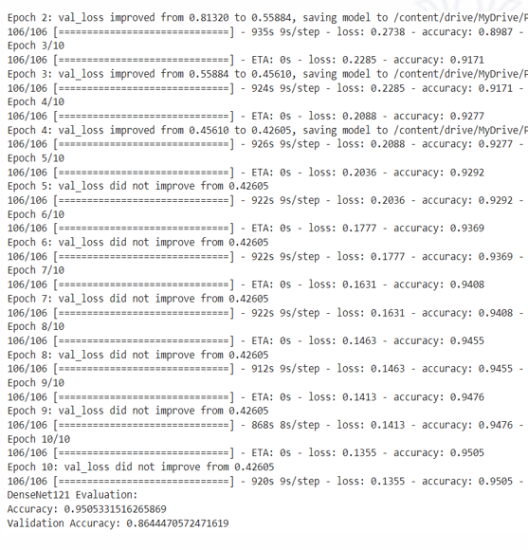

Fig 7.2 Accuracy of DenseNet Architecture

The accuracy of DenseNet architecture is 0.9505 and the loss denote as 0.1355. To tune the model for better accuracy it takes an epoch size of 10. The evaluation for validation accuracy is 0.864447 in Fig 7.2. The accuracy for ResNet architecture is 0.91 percent. The precision, recall, and f1 scores for each class have been predicted.

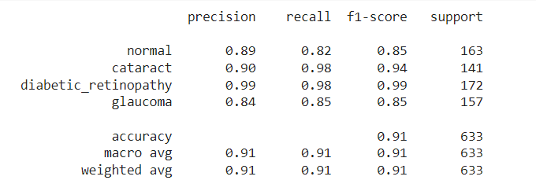

Fig. 7.3 Accuracy of ResNet Architecture

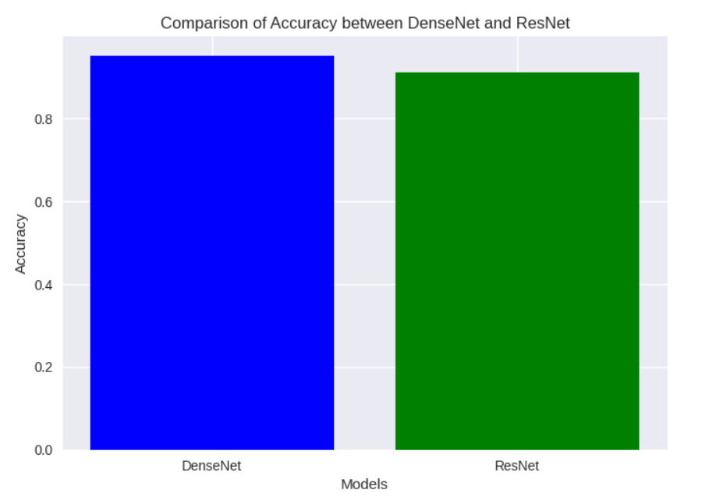

Fig. 7.4 Comparison of both algorithms

Fig 7.4 represents the comparison of both algorithms using

Bar Chart. The Bar Chart shows that DenseNet architecture has a high accuracy of 95% when compared to ResNet architecture

of 91%.

VIII. CONCLUSION

The conclusion of the project states that DenseNet architecture has secured high accuracy when compared to ResNet architecture for the ‘Eye Disease Classification’ dataset. The DenseNet achieved 95% and ResNet achieved 91% of accuracy. The DenseNet accurately finds eye diseases and categorizes them into the classes where the disease belongs. It also helps doctors to diagnose early and prevent a person from eye diseases. Overall, the outcomes emphasize the capability of employing highly developed models in deep learning which improves optical care and patient welfare.

IX. FUTURE SCOPE

The proposed work is done with an image dataset and originated from the Kaggle repository, a common platform for datasets and tools of data science. Regardless, we can’t collect real-time data to implement the model. This is a drawback of the paper. The accuracy of the proposed work is 95% and 91% for DenseNet architecture and ResNet architecture. To improve model performance, advanced techniques of deep learning like Vision transformers and EfficientNet can be integrated. The datasets can be expanded by collecting data on various eye diseases beyond cataracts, diabetic retinopathy, and glaucoma can also include other eye diseases like AMD, dry eye syndrome, etc...

X. REFERENCE

[1] Jiang, H., Hou, Y., Miao, H., Ye, H., Gao, M., Li, X., Jin, R. and Liu, J,(2023),’ Eye tracking based deep learning analysis for the early detection of diabetic retinopathy. a pilot study. Biomedical Signal Processing and Control’.

[2] Peng, Z., Li, Z., Yin, C., Li, R. and He, C, (2024),’ Near-infrared fundus imaging diagnostics device based on deep learning classification and infrared thermography in ophthalmology. Journal of Radiation Research and Applied Sciences’.

[3] SAraújo, T., Aresta, G., Mendonça, L., Penas, S., Maia, C., Carneiro, A., Mendonça, A.M. and Campilho,(2024),’ DR GRADUATE Uncertainty-aware deep learning-based diabetic retinopathy grading in eye fundus images. Medical Image Analysis’.

[4] Santos-Bustos, D.F., Nguyen, B.M. and Espitia, H.E,(2020),’ Towards automated eye cancer classification via VGG and ResNet networks using transfer learning. Engineering Science and Technology, an International Journal’.

[5] Sangeetha, K., Valarmathi, K., Kalaichelvi, T. and Subburaj, S,(2020),’ A broad study of machine learning and deep learning techniques for diabetic retinopathy based on feature extraction, detection, and classification. Measurement’.

[6] Shanmugam, P., Raja, J. and Pitchai, R,(2021),’ An automatic recognition of glaucoma in fundus images using deep learning and random forest classifier. Applied Soft Computing’.

[7] Imtiaz, R., Khan, T.M., Naqvi, S.S., Arsalan, M. and Nawaz, S.J,(2021),’ Screening of Glaucoma disease from retinal vessel images using semantic segmentation. Computers & Electrical Engineering’.

[8] De Zarzà, I., de Curtò, J. and Calafate, C.T,(2022),’ Detection of glaucoma using three-stage training with EfficientNet. Intelligent Systems with Applications’.

[9] Xue, Y., Zhu, J., Huang, X., Xu, X., Li, X., Zheng, Y., Zhu, Z., Jin, K., Ye, J., Gong, W. and Si, K,(2022),’A multi-feature deep learning system to enhance glaucoma severity diagnosis with high accuracy and fast speed. Journal of Biomedical Informatics’.

[10] Ashwini, K. and Dash, R.,(2023),’ Grading diabetic retinopathy using multiresolution based CNN. Biomedical Signal Processing and Control’.

[11] Alshayeji, M.H. and Sindhu, S.C,(2023),’ Two-stage framework for diabetic retinopathy diagnosis and disease stage screening with ensemble learning. Expert Systems with Applications’.

[12] Hacisoftaoglu, R.E., Karakaya, M. and Sallam, A.B,(2023),’ Deep learning frameworks for di+abetic retinopathy detection with smartphone-based retinal imaging systems. Pattern recognition letters’.

[13] Ifrah, A. and Sunness, J.S,(2023),’ Oil droplet cataracts can mimic retinal disease. American journal of ophthalmology case reports’.

[14] Blanco-Vázquez, M., Gil-Cazorla, R., Barua, A., Taneja, M., Hanneken, L. and Shah, S,(2024),’ Impact of thermo-mechanical skin treatment on refraction and keratometry in patients with dry eye disease and the implications for cataract surgery. Contact Lens and Anterior Eye’.

[15] Lin, H., Li, R., Liu, Z., Chen, J., Yang, Y., Chen, H., Lin, Z., Lai, W., Long, E., Wu, X. and Lin,(2024),’ Diagnostic efficacy and therapeutic decision-making capacity of an artificial intelligence platform for childhood cataracts in eye clinics: a multicentre randomized controlled trial. EClinicalMedicine’.